07 Jun 2021
ADSH-2021-967
No
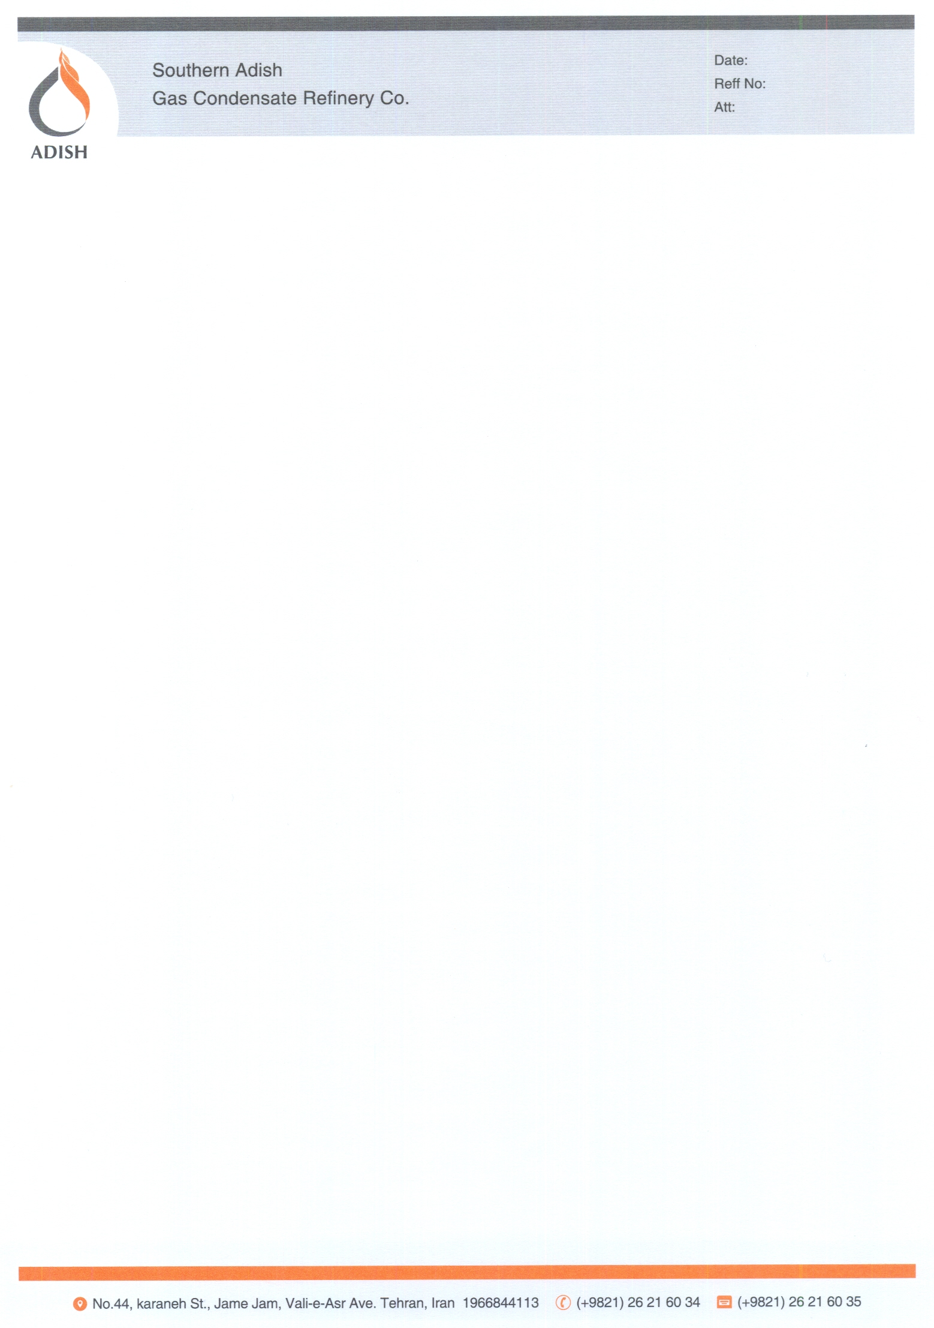

Dir Sirs
For audit purposes would you please fax directly to our auditors, Kooshamanesh Auditing Services Firm No. of 0098 021 8504159, the balances of following accounts at Southern ADISH Gas Condensate Company as your records:

Accounts receivable ------------
Notes receivable ------------
Prepayments ------------

Accounts payable ------------
Notes payable ------------
Advances received ------------

Please notify them if there are any other points in your interrelated accounts.

Yours faithfully
ADISH Co.


